**INSE 691 – Advanced System Modeling and Simulation**



**PROJECT**

**REDUCING WAITING TIME IN RESTAURENT**

**Submitted To**

Dr. Anjali Awasthi

**Submitted By:**

|  |  |
| --- | --- |
| **Name** | **ID** |
| Prabhsimran Kaur Bhullar | 40104070 |
| Kuljit Kaur | 40115525 |
| Taranjyot Singh | 40120880 |
| Jasjit Kaur | 40115629 |

# Introduction

The restaurant is a business that gets ready and serves food and beverages to clients. Restaurants have consistently assumed a basic job in the business, social, scholarly, and aesthetic existence of a flourishing society. Restaurants play an important role in the human need for connection and shaped social relations. The major events of life, personal and professional, are celebrated in restaurants. People like to spend their happy moments in restaurants with their loved ones. For the success of the restaurant, great customer service is essential. Customer satisfaction is an integral part of any restaurant model. But the sudden shock of COVID-19 PANDEMIC has affected day to day life. Since March 2020 the world economy has changed, this situation not only has a profound impact on business but also it impacting the restaurant industry. Earlier there used to be sufficient employees in a restaurant to manage all the work like taking online and in-person orders, preparing the received orders, for making prep. But nowadays due to the COVID-19 crisis, the majority of the customers avoid visiting the restaurants instead they prefer to make online orders. Taking this as a consideration in some restaurants only one employee is scheduled at one time to handle the whole work in a restaurant. But, this has resulted in long waiting times for customers. Firstly customers have to wait too long for placing their orders secondly they spend a long time waiting to receive the order. Moreover, the drivers who visit the restaurant to receive online orders also have to wait for a long period. Therefore, waiting time in a restaurant is a major issue in the restaurant.

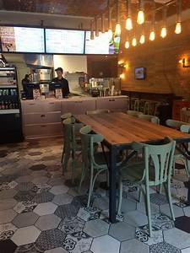

## Objective:

For solving this problem, we have used different models to simulate like Arena, Vensim, Monte Carlo, all these models change situations by reducing the waiting time of customers. Using our best model, we implement changes in the default structure to increase the flow schemes of customer’s service waiting time. To develop this model and examine various scheduling scenarios, we studied the workflow of customers to collect all required data and developed a starting point of the base model using simulation software named ARENA.

## Literature review:

In today’s era, the demands of goods are increasing day by day. Nowadays, folks love to eat food in that case, fast food restaurants are also burgeoning. Today, people are so busy in their works that they don’t have time to prepare food so they mostly prefer to have food in restaurants. The rate of incline in fast food expenses has taken a big place in the market as compared to home food. Nowadays, people don’t spend money on home food, they prefer to go to restaurants. This scenario has taken place from the last 2 decades. According to the latest data, there is an increase in the rate of consumer expenses at fast food. The customers prefer to visit fast food outlets and they are going far away from home food. The major events of life, personal and professional, are celebrated in restaurants. Restaurants are the last bastion of urban manufacturing and, as such, create a massive number of jobs. The industry currently employs 10% of the entire US workforce and this number continues to rise. The National Restaurant Association estimates that nearly 15 million people will work in the industry by 2024.

The atmosphere of a restaurant is very important for many factors. But owners of the restaurant have to pay attention to the look of their dining room as same as the food they serve and the facilities they provide.

# INPUT MODELLING

Certain assumptions have been made to ease the running of this project which are as under:

1. The customers arrive with the Poisson arrival rate.

2. The hypothesis of Triangular distribution is used.

3. A discrete model simulation is carried out to create a simulation for the restaurant.

4. The service rate is exponential.

**RESTAURANT OPERATIONS**

1. Restaurant duration: 8 am to 11 pm.

2. One counter for ordering, payment, and queries.

**MODEL ASSUMPTIONS**

1. The customer enters the restaurant and exits after being served by the staff.

2. There are no other external or internal factors influencing customer satisfaction.

**RESTAURANT DESCRIPTION**

The restaurant chosen is COPPER BRANCH located in Downtown, Montreal working 7 days a week with 15 hours operational shift every day.

**Type of customers:**

1. General customers

2. Online orders

3. Regular customers

The restaurant has one counter for regular, general queries, online orders, and payment. Employee 1 at the counter take orders, handles online orders, also answer general queries, and receive payment. Employee 2 handles stock in the kitchen, prepares customer’s orders and online orders.

**GOODNESS OF FIT-TEST**

To analyze the input data, an input analyzer in the arena is used and the chi-square and Kolmogorov-Smirnov test is used to find the goodness of fit test. It is found that Triangular distribution is best for both the default system and the proposed best configuration.

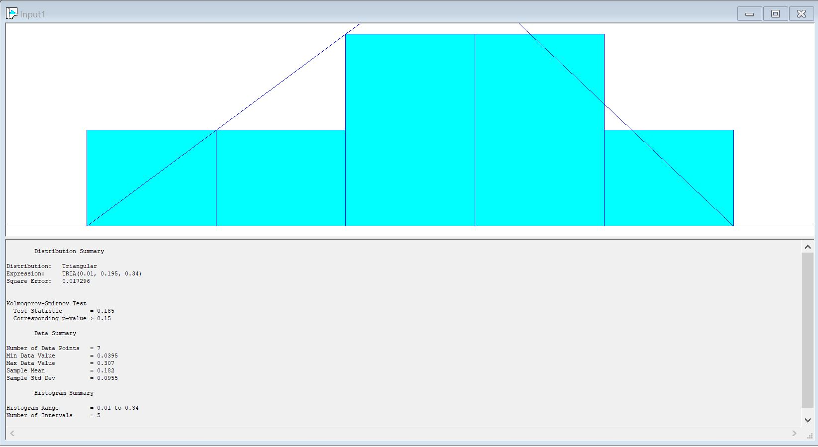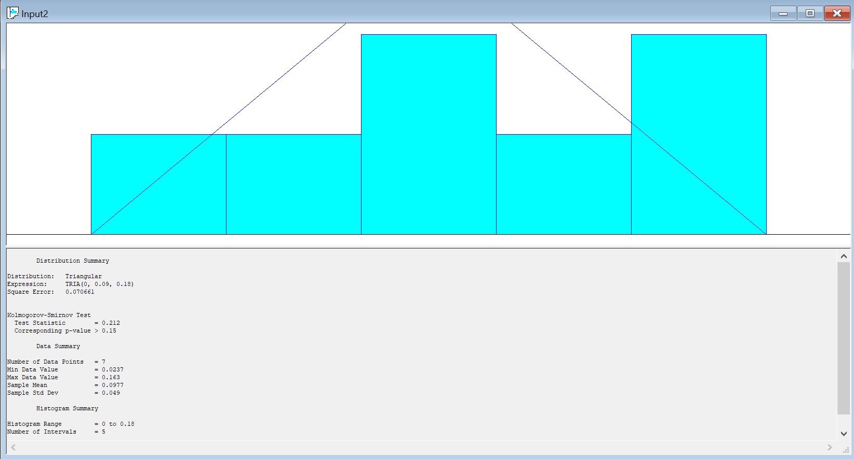

# Model Design:

To design the process, Arena is implemented. In our restaurant system, discrete event simulation is used. We decided to choose this model, in our model state variables changes with respect to time and for this, some activities change the system states.

**Problem:** Customers spend a large amount of time waiting in the queue.

**Entities**: Customers

**Attributes:** Waiting time, Service time, the Arrival time of customers, bilingual (English, French) employees

**Queues**: Queue of customers

**Resources**: counters, employees, queues, Staff, authority, property

**Events:** Arrival of customers, departure of customers

**State Variables**: Numbers of customers, service time

**PRESENT SYSTEM**

In our project, we considered real data of fast-food restaurant COPPER BRANCH in Montreal, downtown and it is compared with our proposed model. In the existing model, there are 2 employees Employee 1 and Employee 2. Employee 1 handles regular orders, online orders, and general queries. Payment is also handled by Employee 1. Employee 2 works in the kitchen who prepares in person and online orders. Employee 2 handles all the duties of the kitchen which is being held in the kitchen. There are 2 employees only in the restaurant so all work is done by 2 employees which increases the waiting time of customers, due to which customer satisfaction decreases. But during peak hours, it creates a lot of problems in the restaurant. In this model, it is described that the waiting time is high because there are only 2 employees who are handling the entire restaurant due to which the customers have to wait too long not only in placing the order but also receiving the order. The following picture is the process map implemented in Arena.

**PROPOSED SYSTEM**

To solve the problem of the waiting time of customers, the following configurations are suggested and implemented.

**Configuration 1:**

Employee 1 is responsible for receiving the in-person and online orders, take payment, and also solve the queries of the customers.

Employee 2 prepares in-person and online orders and handles these to employee 1.

Employee 3 prepares inventory in the kitchen and provide needed stuff to Employee 2.

**Configuration 2:**

Employee 1 is responsible for receiving the in-person and online orders, take payment, and also solve the queries of the customers.

Employee 2 prepares in-person orders and handles these to employee 1.

Employee 3 prepares inventory in the kitchen and provide needed stuff to Employee 2 and Employee 4.

Employee 4 prepares the online orders and handover these orders to Employee 1.

**Configuration 3:**

Employee 1 is responsible for receiving the in-person and online orders, take payment, and also solve the queries of the customers.

Employee 2 prepares in-person orders and handles these to employee 1.

Employee 3 prepares inventory in the kitchen and provide needed stuff to Employee 2 and Employee 4.

Employee 4 prepares online orders.

Employee 5 segregate the online and in person orders and serve the orders to customers.

**Configuration 4:**

Employee 1 is responsible for receiving the in-person and online orders, take payment, and also solve the queries of the customers.

Employee 2 prepares in-person orders and handles these to employee 1.

Employee 3 prepares inventory in the kitchen and provide needed stuff to Employee 2 and Employee 4.

Employee 4 prepares online orders.

Employee 5 segregate the online and in person orders and serve the orders to Employee 6.

Employee 6 at new counter 2 serves the orders to customers and receives the payments.

## Process map

The process map is the graphical characterization with an interpretative explanation of step by step working of the current system. This process map helps us to envision the details of the waiting time closely and it guided us in our decision-making technique which we used to reduce the long waiting time of customers. The following process map is the representation of our present system.

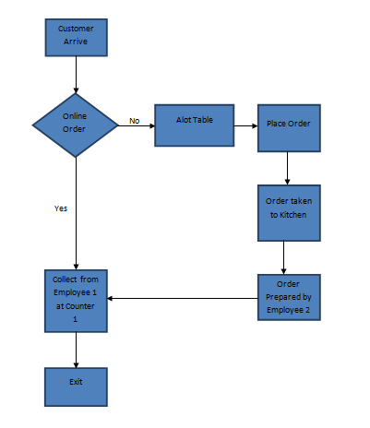

## Discrete Event Simulation (Arena)

Arena describes a breakthrough in simulation technology by allowing enterprise-wide simulation. It is an extensive system that directs all phases of a simulation project from input data analysis to the analysis of simulation output data.

**Original Configuration**

The following diagram represents the arena simulated model of the existing (default) system.

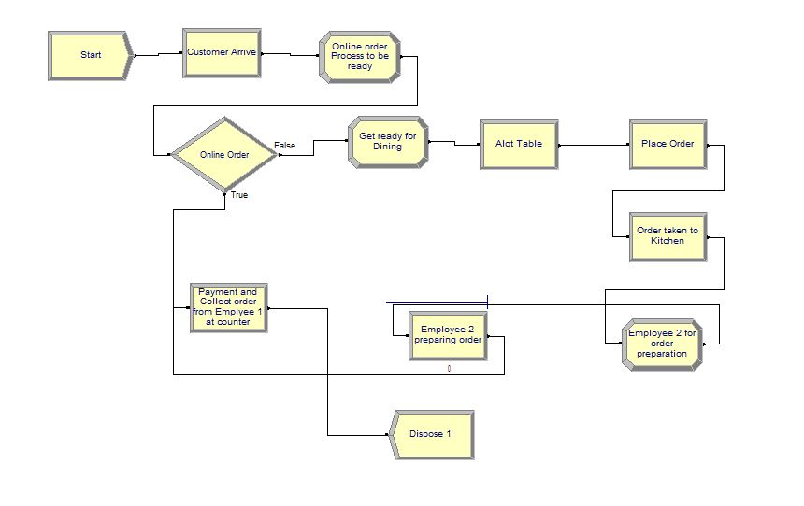

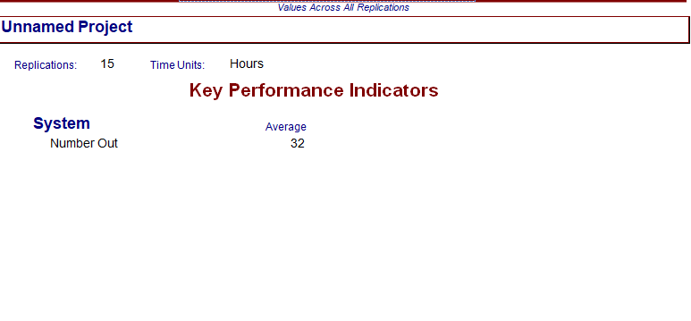

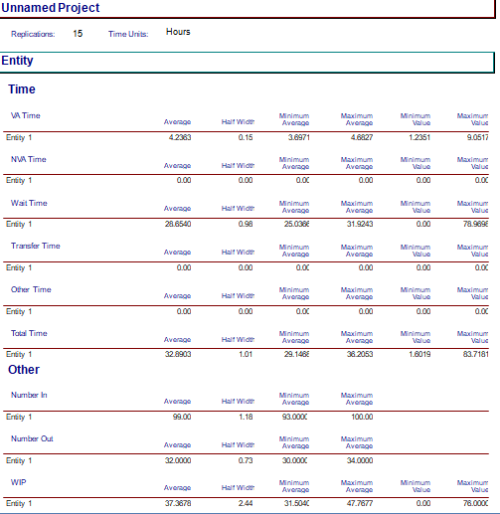

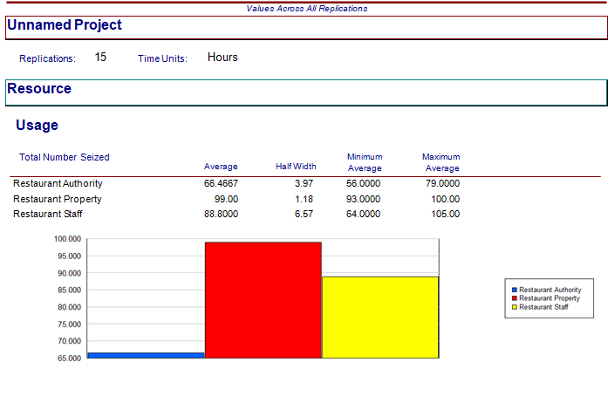

According to this configuration, the average time a customer spends in the system is 28.65 minutes and the maximum value it can extend to is 78.96 minutes. A large amount of time spent in waiting reduces customer satisfaction. So, the main focus is to reduce the waiting time for which we proposed different alternative configurations and out of these, the best is selected.

**Configuration 1**

In this configuration by increasing the employee in the kitchen the average waiting time was reduced to 27.55 minutes.

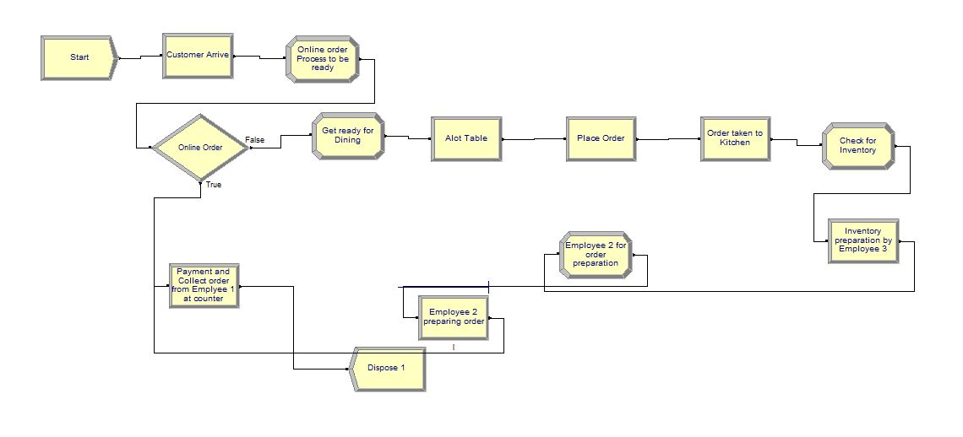

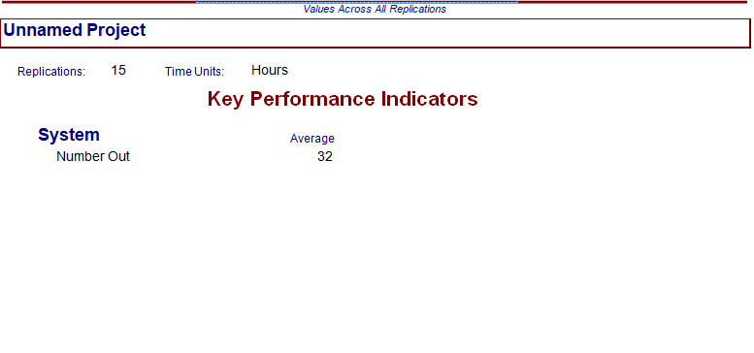

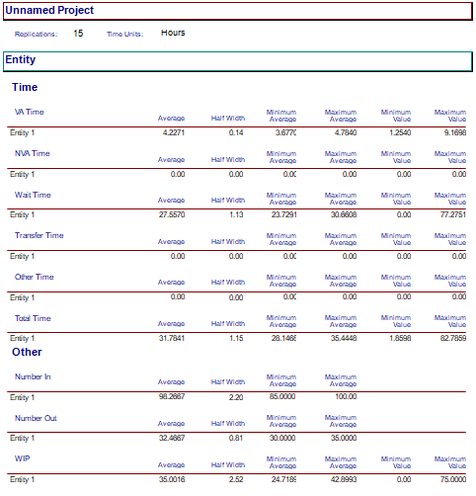

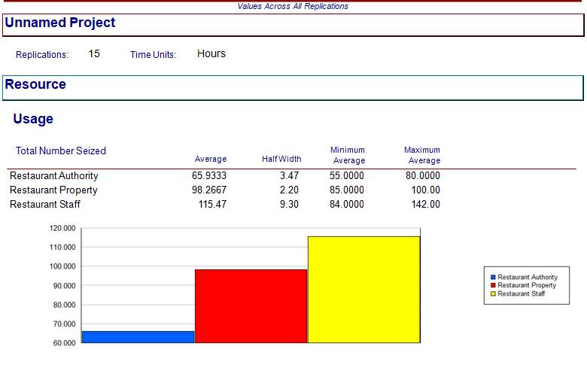

**Configuration 2**

In this configuration, 2 employees were increased in addition to the original number of employees.

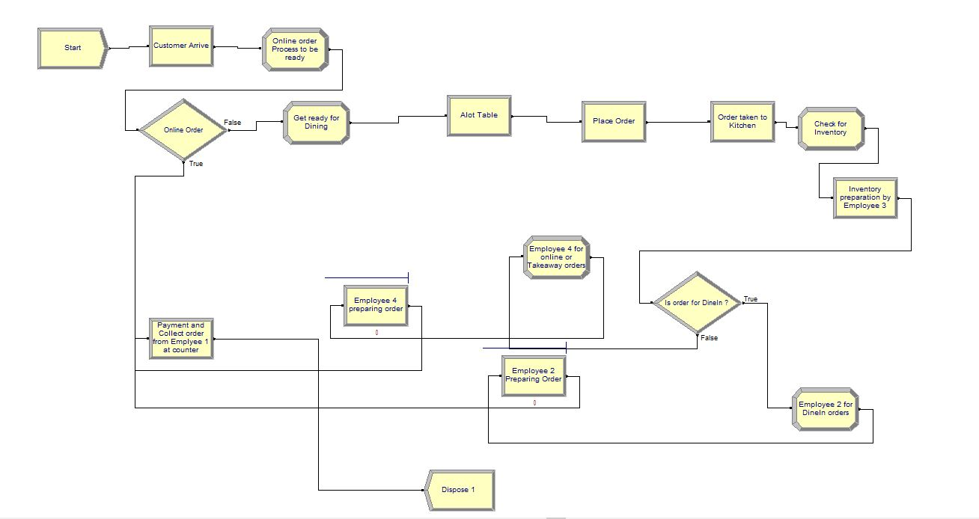

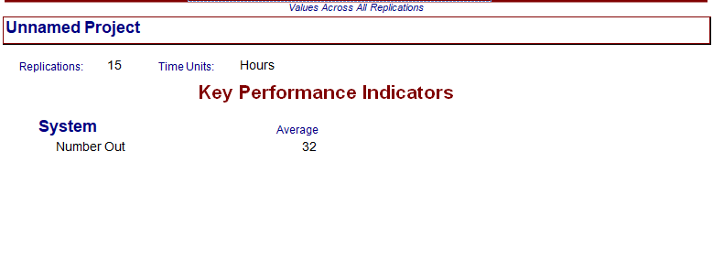

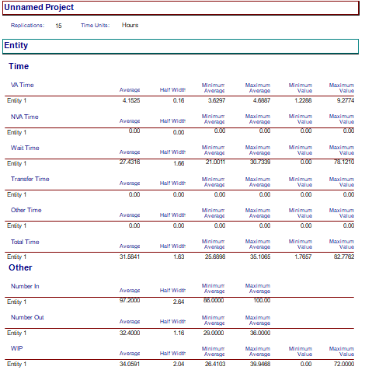

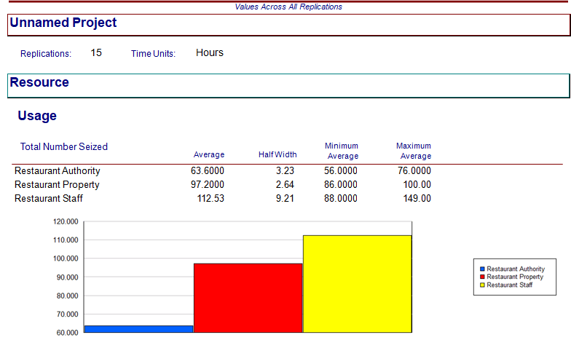

**Configuration 3**

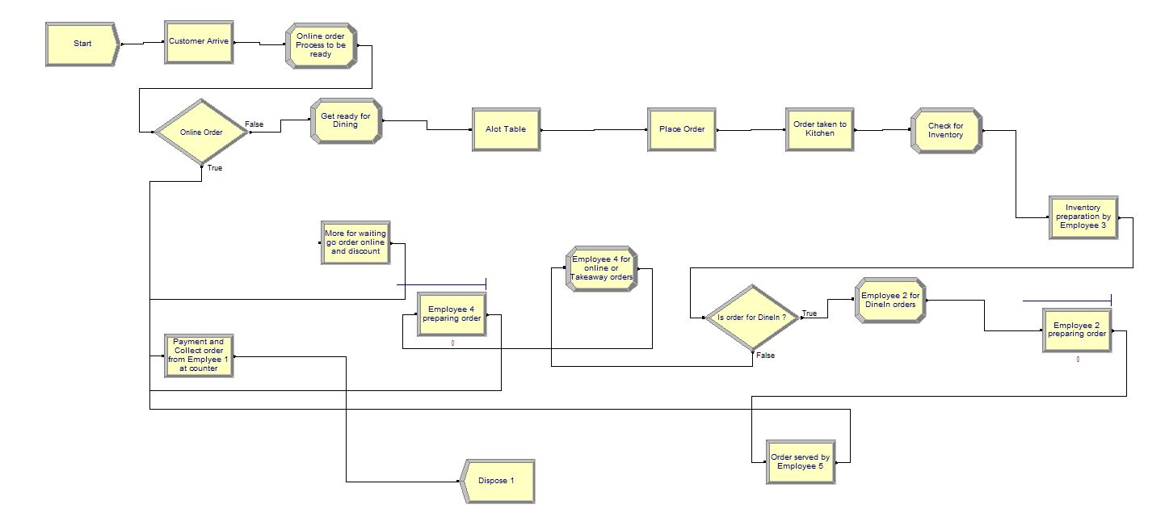

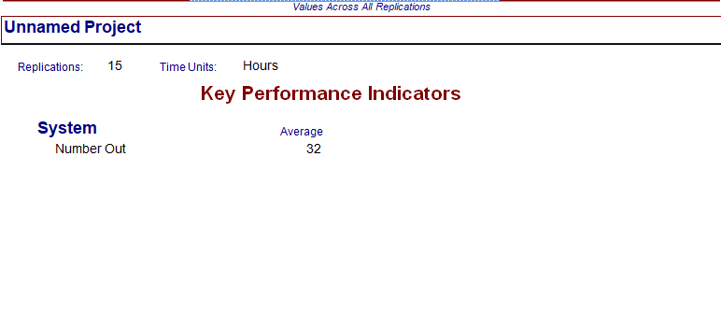

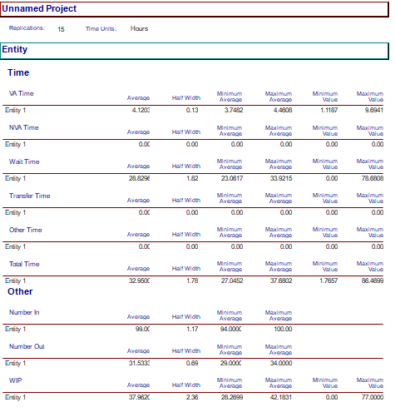

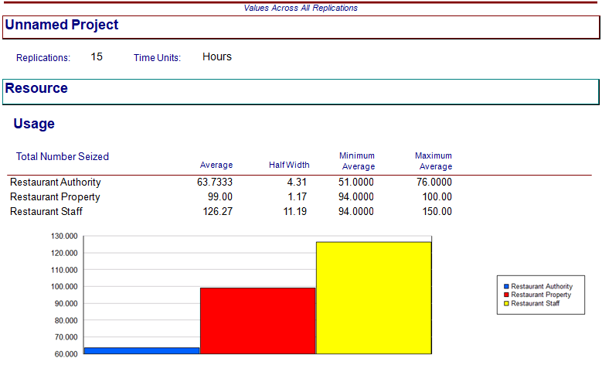

**Configuration 4**

In the final proposed configuration by increasing the number of employees to 6 and by adding one more counter the waiting time is reduced to 5.71minutes.

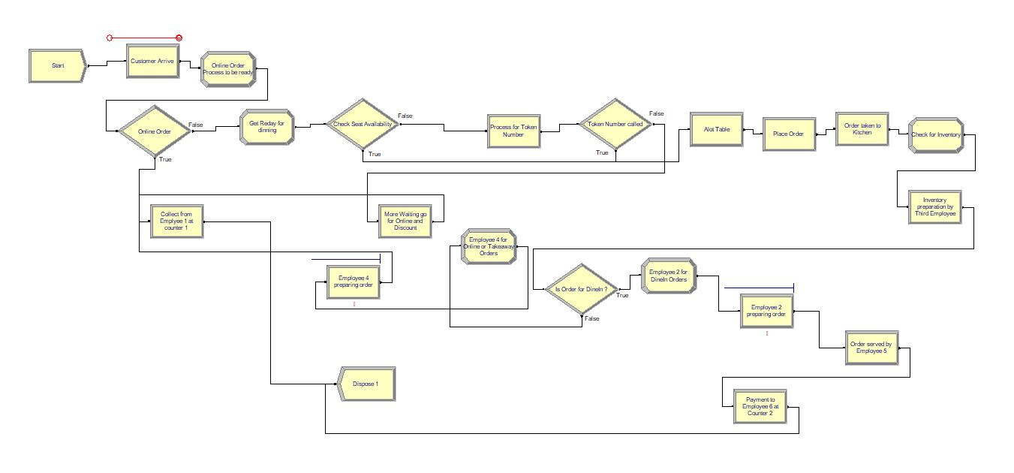

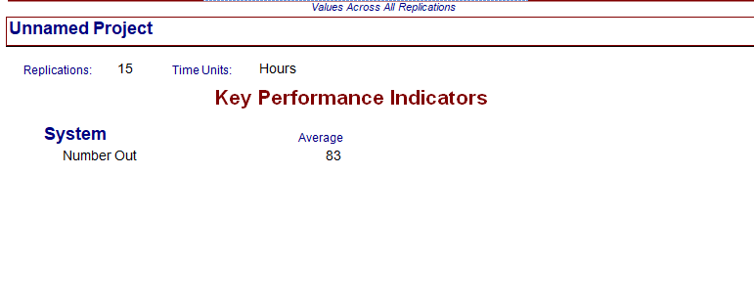

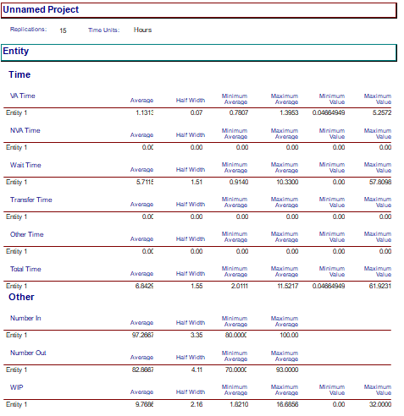

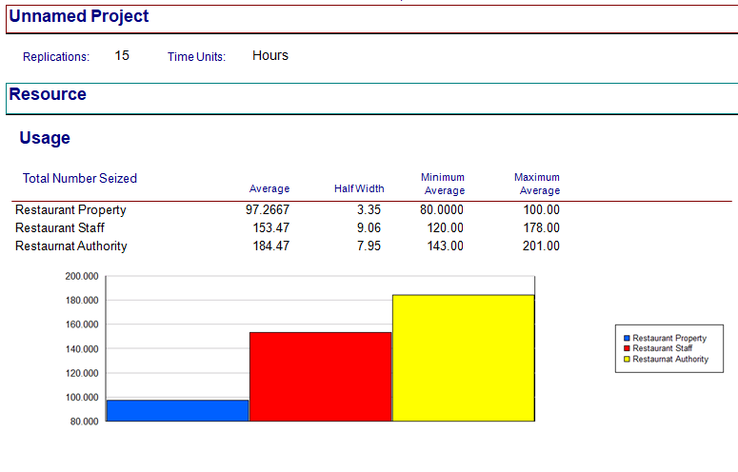

**Verification and Validation**

**Verification**

For our model the entity is customers, events in the system are arrival and departure of customers and waiting time, service time, the arrival of customers, employees are attributes of the system.

**Static Testing**: In static testing, we found that when there are only two employees in the restaurant, and the number of customers is high the waiting time is very high. Because when customers arrive in the restaurant, firstly they have to wait for placing their orders and then in receiving their orders. This system was working in the simulation software without any error.

**Dynamic Testing**: In the system, it was found that when we have given arrival rate as 20 customers per hour and the number of employees is 2, the waiting time for the queue is very high. Then we tested the model by changing the inputs i.e. the number of employees and found that the output i.e. the waiting time is reducing.

**Validation**

Two validation techniques were implemented, and they are degenerate tests and event validity.

**Degenerate tests**:

The perversion of the model is tested. We found that as the number of customers arriving in the restaurant increases the waiting time of customer queue also increases. Initially, when there are 20 arrival customers in the system the waiting time for customer queue is 35-40 minutes. When the arrival rate increases to 45 customers than waiting time also increases to 80-85 minutes.

**Event Validity**:

The simulated system is compared with real-world restaurant Copper Branch, Downtown Montreal. The input parameters and different events such as arrival and departure of customers, waiting time, and service time are compared with the real world restaurant and it is found that both are similar.

## System Dynamics Simulation Model (VENSIM)

In order to understand how the system changes with respect to time, we used system dynamics simulation. In this model, we observed that concerning the change in input the output also changed by the same amount similarly, with the change in the output there is a change in the input also.

**Original Configuration**

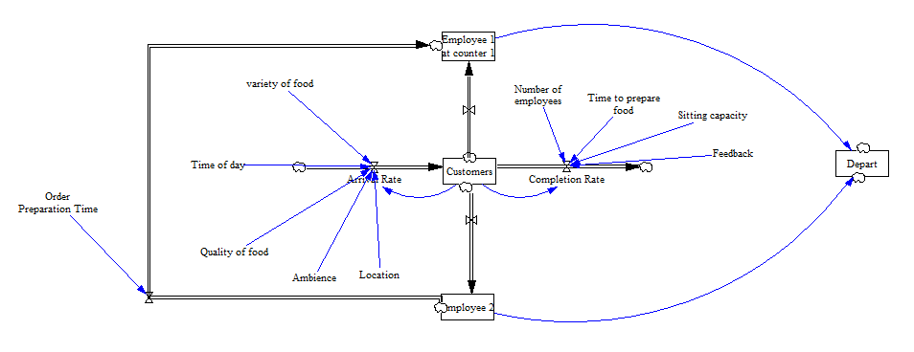

Here, we will create a system dynamics simulation model based on the Stock and flow diagram.

The initial values of the stock-flows and variables are needed to be defined.

**Customers**

The ideal goal is to reduce the waiting time of customers at a restaurant to increase customer satisfaction.

**Arrival rate:**

It is defined as the number of customers arriving in a given period. Arrival rate depends on different variables which are defined following:

**Variety of food:** In any restaurant, the food variety attracts more customers. So, if the restaurant has different types of foods the arrival rate of customers will be high.

**Quality of food:** Food Quality have a major effect on the customer arrival rate. Better the quality of the food more is the customer arrival rate.

**Time of day:** The restaurant service is available from 8 am to 11 pm. In a day different periods has different rates of customer arrival. For example, the arrival rate is more during the afternoon i.e. during lunchtime and evenings.

**Ambiance:** The first impression of the restaurant is created by its looks, cleanliness.

**Location:** The location of the restaurant is very important to increase the arrival rate of customers.

Customer Arrival rate = variety of food*quality of food*time of day*ambience*location

**Completion rate:**

It depends on different factor defined as follow:

**The number of employees:** Employees are an important part of restaurants. Higher the number of employees, less the completion rate.

**Time to prepare food**: Food preparation time should be as small as possible to reduce the waiting time of customers.

**Sitting capacity:** Sitting capacity should be more to attract more customers.

**Feedback:** Employee feedback by customers will improve the system by removing the negative points of the systems, which will help the employees to complete the orders in less time.

**Food Cost**: The cost of the food will affect the arrival rate. If the food is expensive, the number of customers arriving will be less.

**Service Rate**: Service rate is defined as the rate at which the customers are being served.

**Configuration 1**

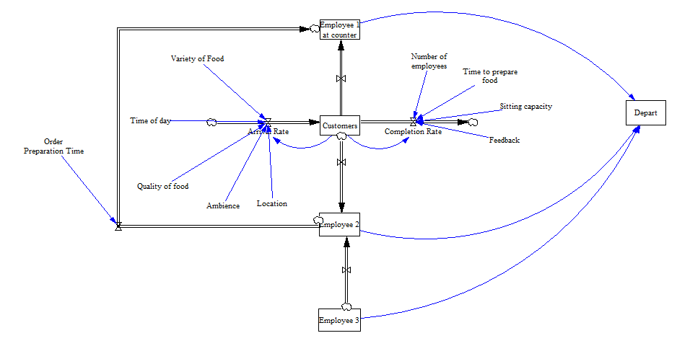

**Configuration 2**

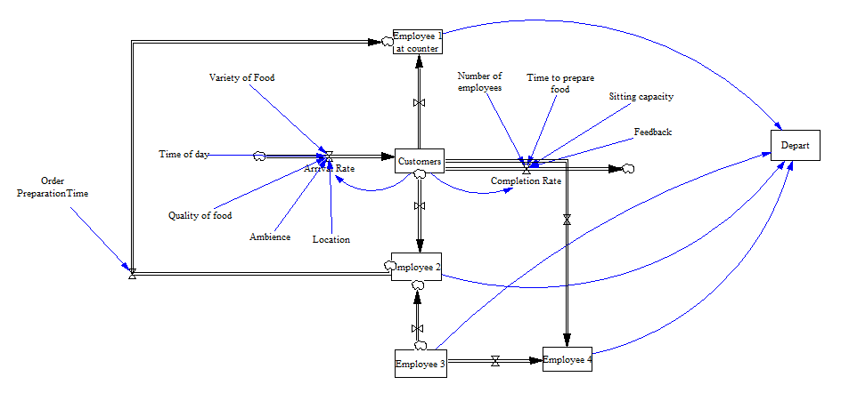

**Configuration 3**

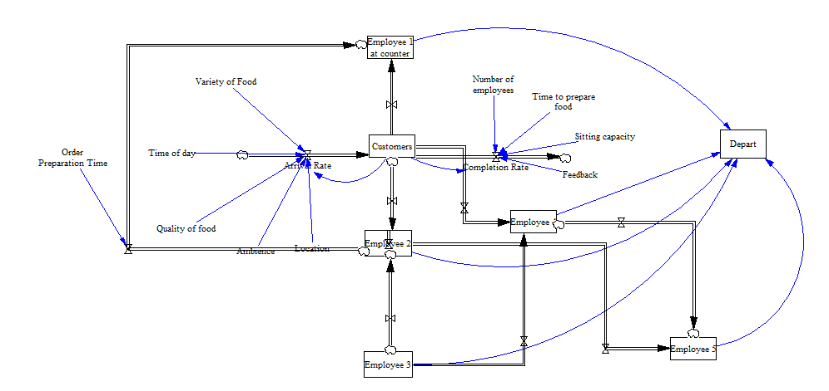

**Configuration 4**

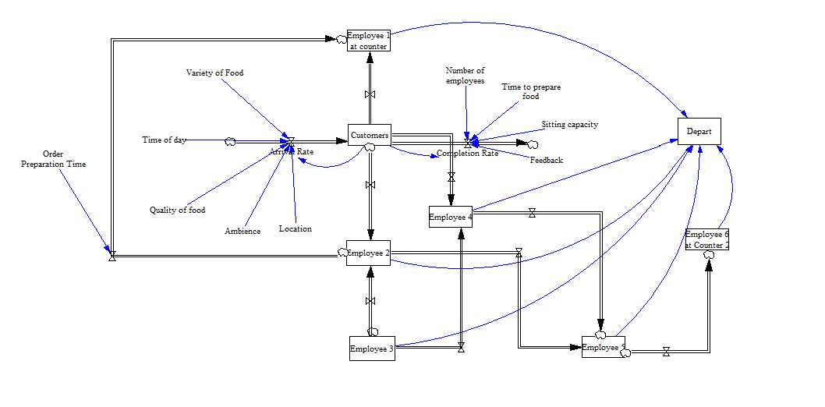

**Output Analysis**

The following diagrams represent the output of vensim models.

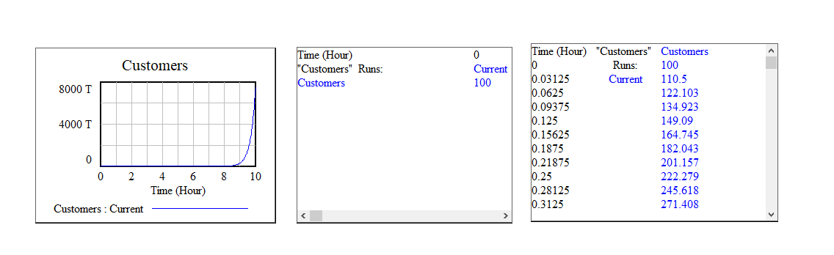

**Causal loop diagram**

It shows the causal connection between the level and rates in a framework. In the causal circle outline, there are two sorts of criticism that is certain input and negative input. As the level and rate cannot be especially portrayed in a causal circle chart, so we expect that those are a few factors that impact each other powerfully.

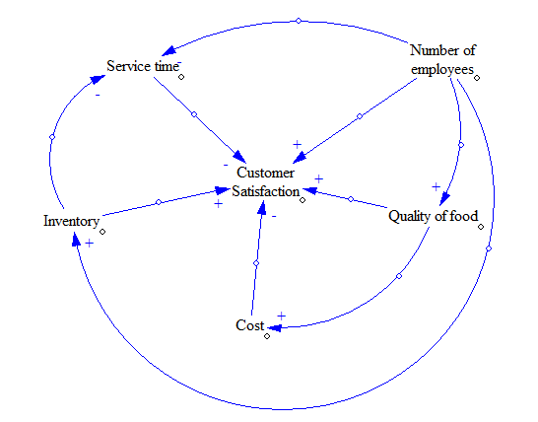

The perfect objective is consumer loyalty. Beginning with a number of workers, if the quantity of employees is more the administration time taken would be less and it will at last lead to a positive criticism towards consumer loyalty. In the event that the food quality is acceptable, the criticism would be sure and consequently, it would look after cleanliness. On the off chance that the quality is acceptable, the expense of the food would be more which will prompt a negative input towards consumer loyalty.

**Verification and Validation**

**Verification**

The verification will be done by performing two different tests –

**Static Testing**: The structure of the model is same as this present reality situation to such an extent that is the administration time taken is the less than the clients holding up in the line will be less. There are a few different constraints that influence, for example, the service time, cost, inventory, quality of food, number of employees, variety of food.

**Dynamic Testing**: In unique testing, various sources of information are utilized, and comparing yields are watched. Our model has been tried with various arbitrary data sources and comparing yields is watched. At the point when the quantity of counters, the number of representatives, and the limit is less than the administration time taken is more.

**Validation**

Two different techniques are used that are the following:

**Degenerate tests**: The decline of the model is tried. At the point when the appearance pace of the clients has expanded then the holding up time in the line is additionally expanded and the equivalent is reflected in the model.

**Event Validity**: Occasion legitimacy strategy is performed to ensure that the occasions in our system dynamics model resemble this present reality situation. In our model, we have utilized the appearance of clients, number of representatives, number of employees, number of counters.

## Monte-Carlo model

Monte Carlo simulation has a wide range of applications in the field of random variables. These simulations are used to represent the probability of distinct outcomes in a process which are not easy to the interposition of random variables.

**Sensitivity Analysis:**

The sensitivity analysis is a technique that is used within limited constraints which are dependent on either one or more than one input variable. The different input parameters are the number of customers, the number of counters, the number of staff members, number of leftover customers, and the output is simulated waiting time.

Below is the default configuration of the system in which the number of counters is 1 and number of employees, is 2. It is found that due to a large number of the customers and a smaller number of employees the waiting time of the customer queue is very high. The following is the list of different input parameters.

**Pre-configuration:**

**Number of Customers:** This input parameter is the representation of the total number of customers who are arriving in the restaurant.

**The number of staff members**: Number of staff members represents the total number of employees who are working in the restaurant.

**The number of leftover customers**: Number of leftover customers is the representation of those customers to whom the employees were not able to serve due to busy in their respective duties.

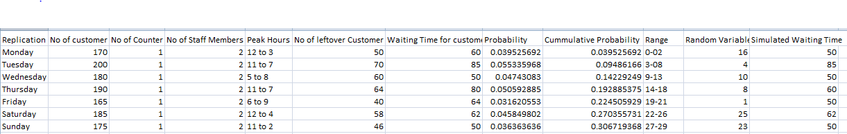

In the pre-configuration scenario, the problem of waiting time is discussed with respect to different input parameters as shown in the graphs below. In the first figure, it is described that during the different days of the week depending on the number of customers arriving in the restaurant during different peak hours the waiting time is high. Further, the second graph indicates that initially when there was only one counter in the restaurant customers have to wait too long to place their order. Moreover, the graphical representation of the number of staff members vs simulated waiting time represents that a smaller number of staff members result in increasing the waiting period of customers. Lastly, no leftover customers vs simulated waiting time graphical representation depicts that as the delay period of placing the order is high, therefore, a significant number of customers left the restaurant rather than standing in the queue and wait for their turn to visit the cashier.

Simulated Waiting Time VS No of Customers

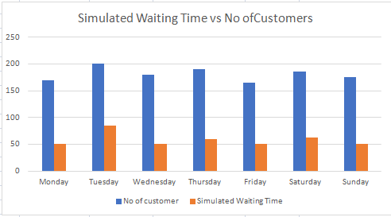

No of Counters vs Simulated Waiting Time

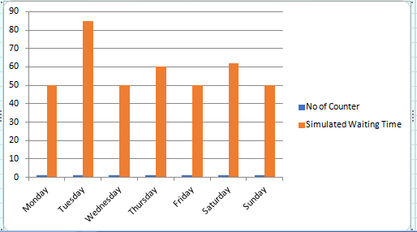

No of Staff Members vs Simulated Waiting Time

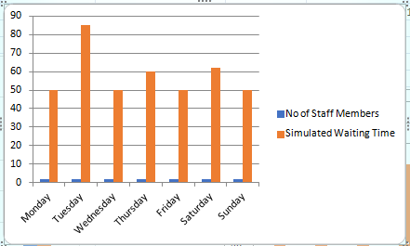

No of leftover customers vs simulated waiting time

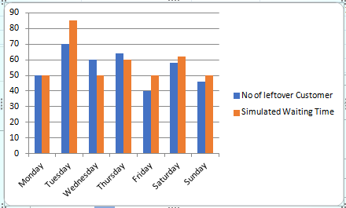

**Post-Configuration:**

In post-configuration, we solved the trouble of long waiting queue by increasing the number of counters by one and the number of staff members are increased by two consequently, there is a reduction in the number of leftover customers and waiting time of customers. From figure () it is clear that the simulated waiting time has decreased compared with the pre-configuration. Secondly, the figure () indicates that the number of counters is increased from one to two the simulated waiting time is reduced by half of the pre-configuration. Furthermore, no staff members vs simulated waiting time graphical representation is an indication of a reduction of simulated waiting time due to an increase in the number of staff members from two to four. Lastly, from the figure () it is understood that as the simulated waiting time is decreased therefore there is reduction in the proportion of number of leftover customers.

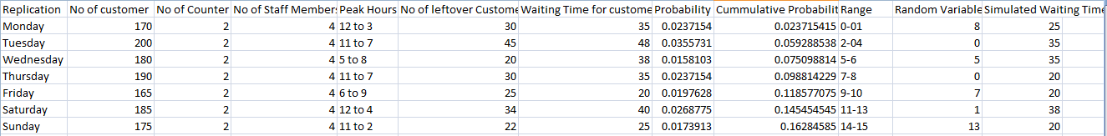

Simulated Waiting Time VS No of Customers

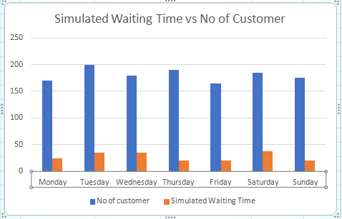

No of counters vs Simulated Waiting Time

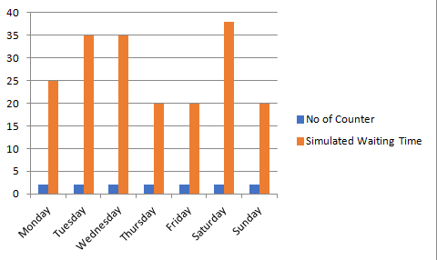

No of staff members vs simulated waiting time

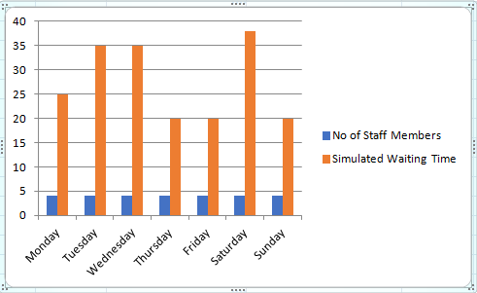

No of leftover customers vs simulated waiting time

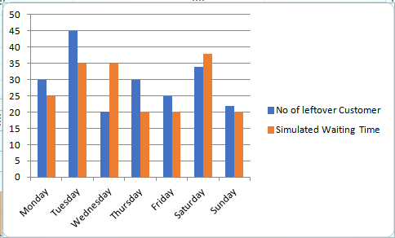

**Verification and Validation**

**Verification**

This model has parameters like the number of customers, number of employees, number of counters, peak hours, and waiting time. All these parameters are present in a real-world scenario.

**Static testing**: Logical structure of the model is the same as the true situation that is holding up time will be decreased if the number of workers and counters is expanded and the client doesn't show up in top hours.

**Dynamic testing:** In dynamic testing, various sources of info are utilized, and comparing yields are watched. This model has been tried with various irregular information sources and relating yields have been watched.

**Validation**

Two different techniques are used to validate the model:

**Degenerate test**: When the number of customers is less, peak hours are less and the number of employees is more than leftover customers are less and their waiting time is less then it will be the default configuration

**Event Validity:**  The events like waiting time in the queue, number of employees, number of customers, number of counters in our model are almost similar In COPPER BRANCH.

# Conclusion:

Initially, the existing system has only 2 employees that increase the waiting time of the customer and decreases the customer satisfaction. In this way, customers stand in the queue for a long time in COVID 19 situation. In this project, we proposed a new model where we increased the employees from 2 to 6 and also increase the counters from 1 to 2. By this, we analyze that customer satisfaction increases due to increase in employees and counters. With this situation, we analyze that this type of implemented system is also helpful in the COVID situation. We implemented the system in the discrete event simulation model, System dynamics simulation, and finally in Monte-Carlo simulation. The system is implemented by given random inputs from the excel-sheet and was analyzed in the input analyzer and Triangular distribution was obtained for given data. Default and proposed configuration were implemented in Arena and we found that proposed alternative configuration 4 has less waiting time than the other alternatives and default configurations. Default data is generated for default configuration and final configuration and we found that waiting time is reduced by increasing the number of employees and number of counters.

**Strengths:**

* Less waiting time in the queue
* Bilingual Staff
* More number of counters
* More number of employees

**Weakness:**

* Less Training
* Less number of counters
* Less number of employees

# References:

# 